**Practical 8**

**Develop an IoT application for monitoring water levels in tanks and automatically start the motor to fill the tank if the level goes below the critical level**

**Steps to Perform:**

**Step 1:** 1) Take LED

2) Take Component - MCU Board

3) Take Motor

4) Take Water sensor

5) Take Water Level Monitor

6) Take Lawn Sprinkle

**Step 2:** 1) Now we will connect LED to MCU Board with IoT custom cable

connect LED (D0) to MCU Board (D0)

2) Then we will connect MCU Board to Water Sensor with IoT custom cable connect MCU Board(D1) to water sensor (A0)

3) Now we will connect MCU Board to Motor with IoT custom cable connect MCU Board(D2) to Motor (A0)

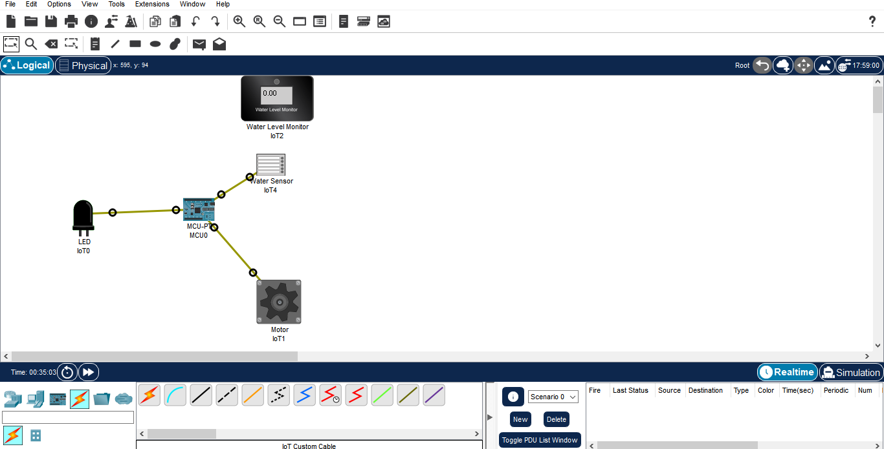

**Step 3:** 1) Now click on MCU Board go to Programming then Select New, Select Template-

Empty-Python then click on Create

2) Click on main.py file then write code

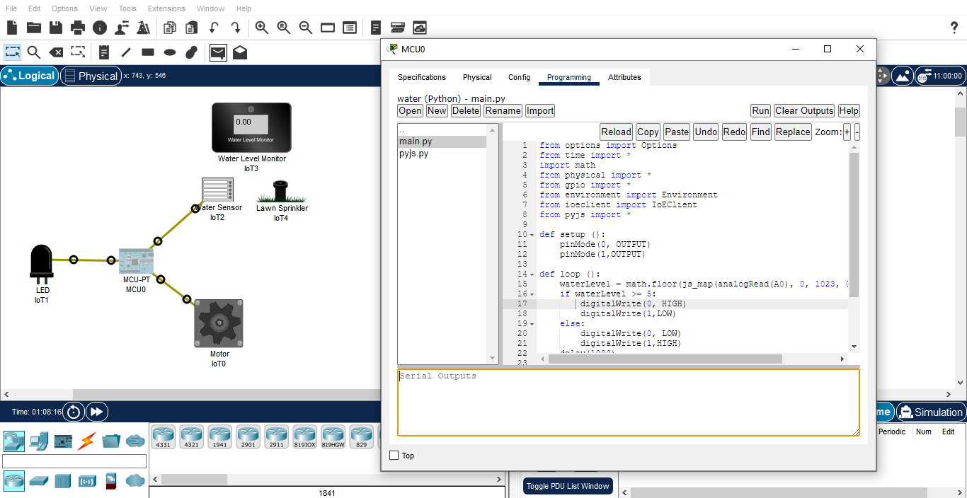

**Code:**

from options import Options

from time import *

import math

from physical import *

from gpio import *

from environment import Environment

from ioeclient import IoEClient

from pyjs import *

def setup ():

pinMode(0, OUTPUT)

pinMode(1,OUTPUT)

def loop ():

waterLevel = math.floor(js_map(analogRead(A0), 0, 1023, 0, 20) + 0.5)

if waterLevel >= 5:

digitalWrite(0, HIGH)

digitalWrite(1,LOW)

else:

digitalWrite(0, LOW)

digitalWrite(1,HIGH)

delay(1000)

if __name__ == "__main__":

setup()

while True:

loop()

idle()

**Step 4:** 1) Now click on MCU Board go to Programming then Select New, Create new python file of name pyjs.py and click on Create

2) Click on pyjs.py file then write code

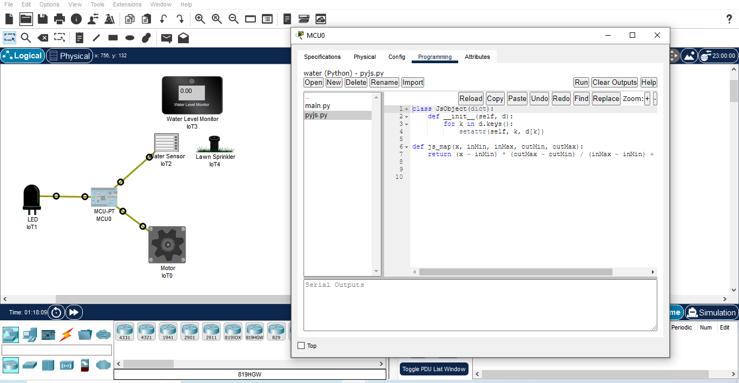

**Code:**

class JsObject(dict):

def __init__(self, d):

for k in d.keys():

setattr(self, k, d[k])

def js_map(x, inMin, inMax, outMin, outMax):

return (x - inMin) * (outMax - outMin) / (inMax - inMin) + outMin

**Step 5:** 1) Click on Run

2) Press Alt button then Start

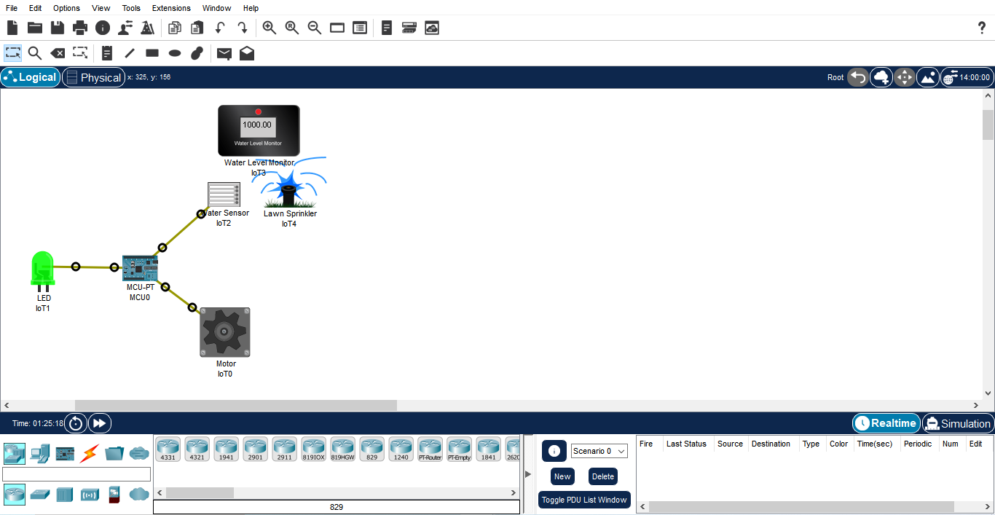

**Step 6:** Wait for some time motor will run automatically.